SMARTDROP COMPANY

1.Overview

This data describe the overall performance of smart drop company. That include data cleaning transformation of data visualization data etc.

2.Dataset information

The raw dataset consisted of four transactional and master files representing the data architecture of Smart Drop Company.

A. Initial Dataset Profile (Before Cleaning)
- messy_customers.csv (520 entries, 4 columns): Contained unique client IDs, names, registration dates, and locations. It suffered from missing entries in all attributes [1] and numerous duplicate client logs.
- messy_order_items.csv (1,930 entries, 5 columns): Logged internal order item codes, parent order keys, product IDs, quantities sold, and final unit pricing. Quantities [1] and unit prices [1] had massive data gaps.
- messy_orders.csv (1,176 entries, 4 columns): Contained transactional data mapping order tracking strings, customer references, purchase dates, and checkout payment routes. It included data voids [1] and duplicated entries.
- messy_products.csv (90 entries, 4 columns): The baseline master inventory category storing stock product IDs, product names, categories, and standard wholesale base costs. More than 60% of the base costs were null.

3. Import libraries
- pandas
- matplotlib
- seaborn
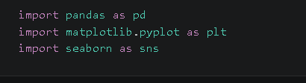
4.Import Data
Import the csv file into python

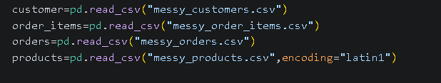

5.Exploratory data analysis (EDA)

The initial source data was highly compromised. To prevent distorted financial statements, the following rigorous data-engineering operations were performed:
- Data cleaning
- Price & Base Cost Vector Imputation:
  - The order_ items table was missing 953 unit prices. These values were imputed using a computed rounded mean of ₹44,755.
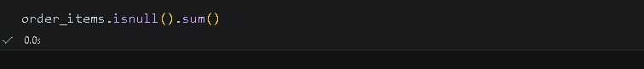

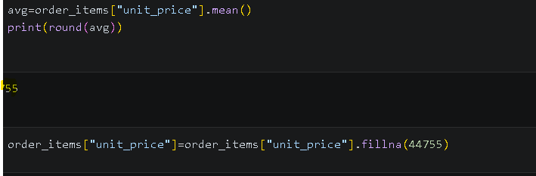

  - The products master category lacked 57 base prices. These fields were imputed using a dataset baseline mean of ₹45,047.


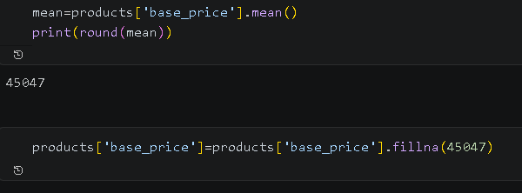

- Transaction Quantity Correction: 305 records contained blank, unrecorded, or zero order counts. These were normalized to a logical baseline value of 1 unit per line item.
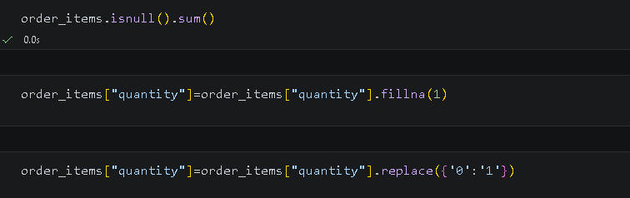

- Text Formatting & Categorical Consolidation:
  - Regional records had significant variations (e.g., mixing 'DELHI', 'delhi', and 'Delhi'). These were unified to proper title-case strings via pandas text operations.

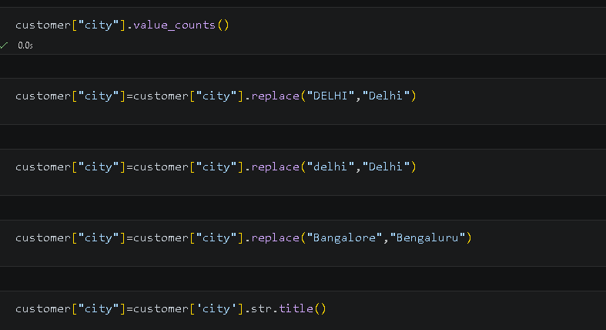

  - Payment avenues (e.g., 'UPI' vs. 'upi') were grouped and standard-cased. Duplicate classifications like 'Cash On Delivery' were merged directly into 'Cash'.
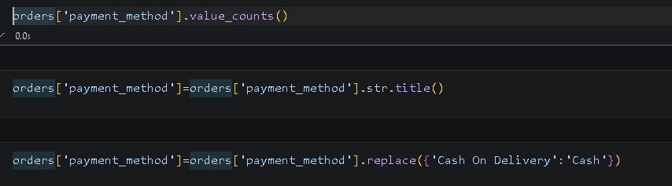

- duplication: Duplicate database logs across all tables were systematically purged (e.g., dropping duplicate rows in customer [1] and orders [1] tables), removing artificial data inflation.




- Tranformating data
Transforming float data type into date datatype using pandas function and extracting month name, year, quarter, etc.

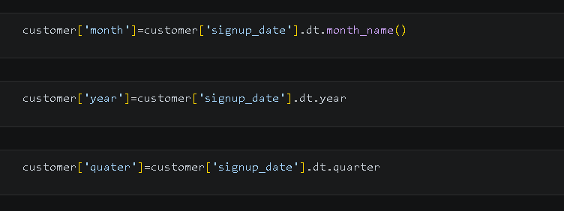

6. Insights
- Total Project Yield: The normalized dataset recorded a total net revenue of ₹158,513,136.0 across its operational lifecycle.
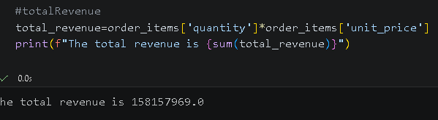
- Year-Over-Year Velocity Drop: Annual performance shows a major financial contraction moving into the subsequent fiscal year:
  - 2024 Net Revenue: ₹107,541,966.0 [1]
  - 2025 Net Revenue: ₹39,898,182.0 [1]
  - Note: This represents a 62.9% drop in annual revenue, signaling either an incomplete ledger handoff or severe business contraction.

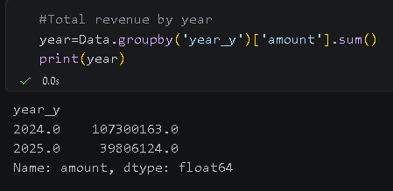

- Product Category Performance:

- By Volume (Quantity): Smartphones are the top-selling segment, moving 1,144 unique units, followed by Accessories (897 units), Tablets (824 units), and Laptops (670 units).
- By Revenue Volume: Smartphones also generated the highest revenue, contributing ₹50,735,746.0. Accessories followed closely at ₹40,712,165.0, with Tablets at ₹37,587,615.0 [1] and Laptops at ₹29,477,610.0.
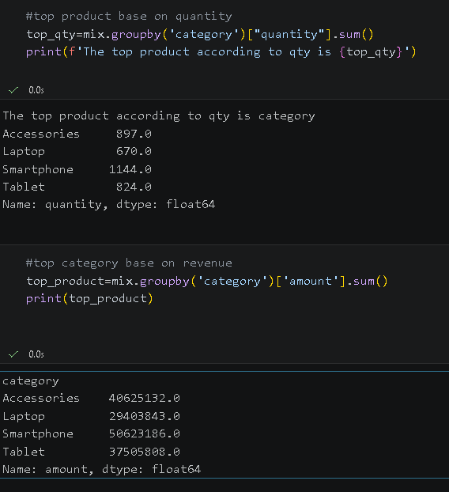

- Geographic Revenue Distribution: Delhi is the brand's primary market, independently generating ₹42,651,840.0 in absolute sales volume. Mumbai (₹22,923,496.0) [1] and Hyderabad (₹20,156,773.0) [1] are the next most profitable territories.
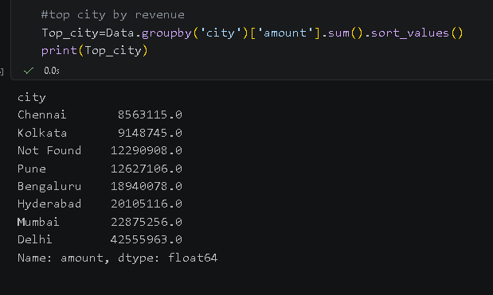
- Cyclical/Seasonal Trends: Net revenue is highly front-loaded, peaking heavily in Quarter 1 (Q1) with an intake of ₹53,293,482.0. Revenue systematically decreased over the remaining quarters, bottoming out in Q3 at ₹25,117,913.0.
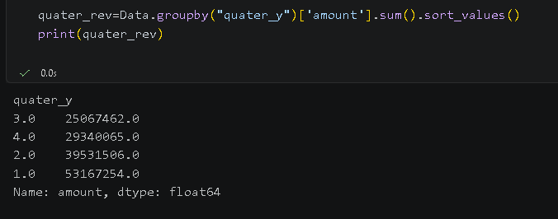
- Client Registrations: User acquisition peaked in 2024 with 768 new customer signups, compared to 707 in 2023 [1] and 314 in 2025.
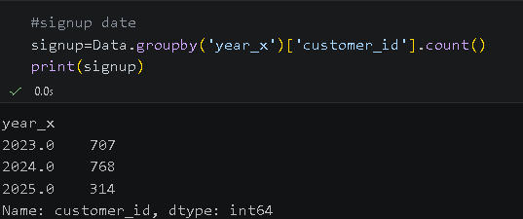
- Fulfillment Portals: Payment avenues are evenly distributed across payment networks. UPI, Credit Cards, and Cash processed an identical volume of 289 successful orders each, while Debit Cards trailed with 126 transactions.
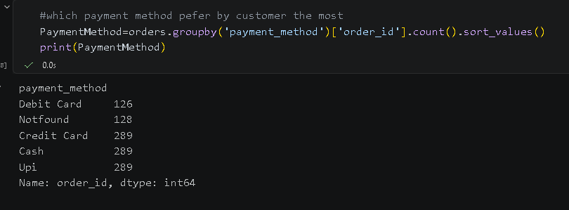

5. Visualization
- Payment Methods Log: A horizontal bar chart shows an identical distribution split (289 orders each) across Credit Card, UPI, and Cash channels, highlighting well-balanced customer preferences.

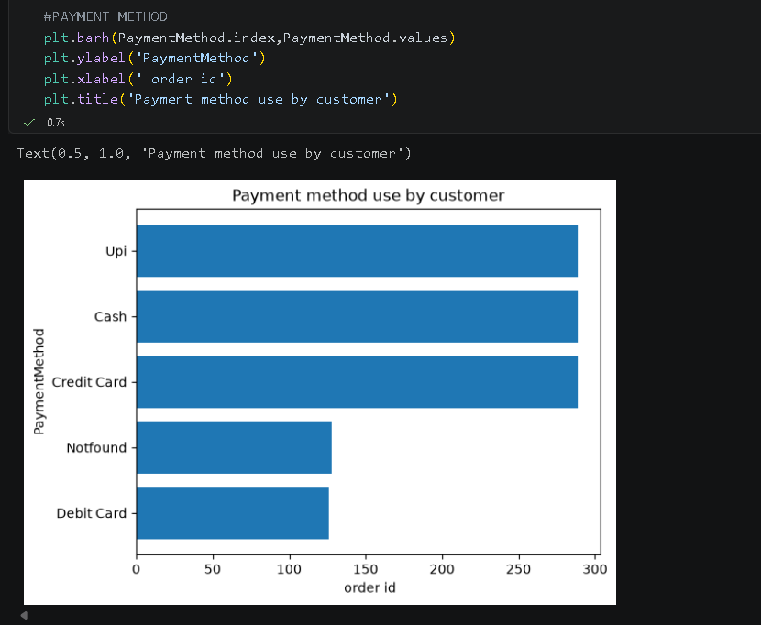

- Product Categories by Yield: A bar chart confirms Smartphones as the clear revenue driver, ahead of Accessories and Tablets, emphasizing where marketing resources should be allocated.
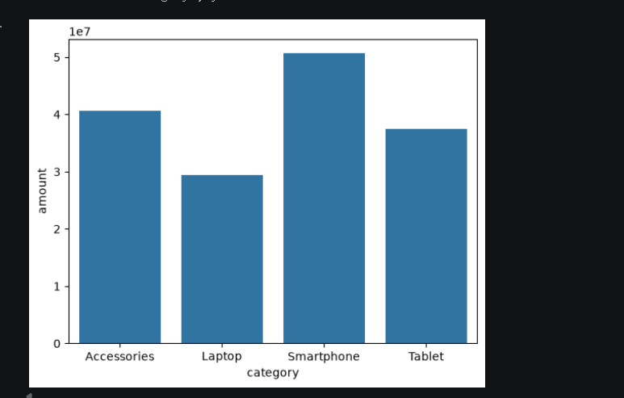

- Monthly Performance: A line chart tracks revenue across the fiscal quarters, clearly showing a peak in followed by a gradual downward slope across the rest of the year.
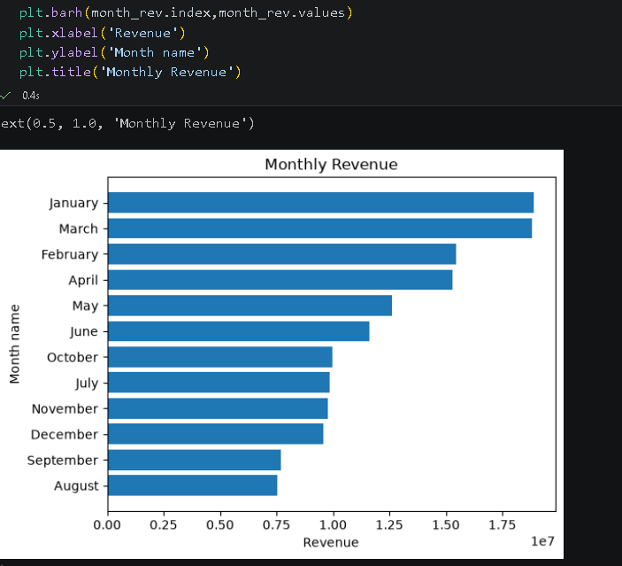
- Regional Revenue Contribution: A horizontal plot visualizes regional performance, placing Delhi far ahead of secondary hubs like Mumbai and Hyderabad.
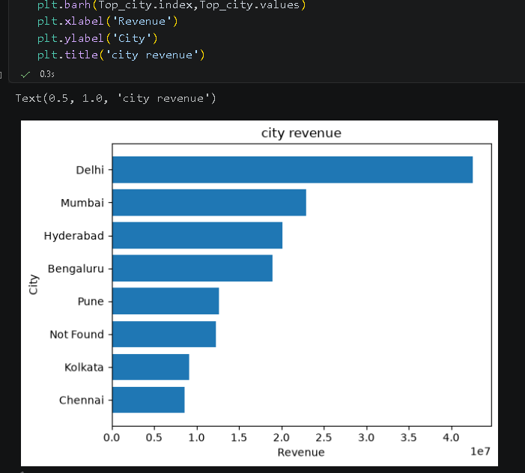

- Customer Base Breakdown: A pie chart illustrates that 2024 was the peak year for new customer signups, reflecting strong marketing and acquisition velocity that year.
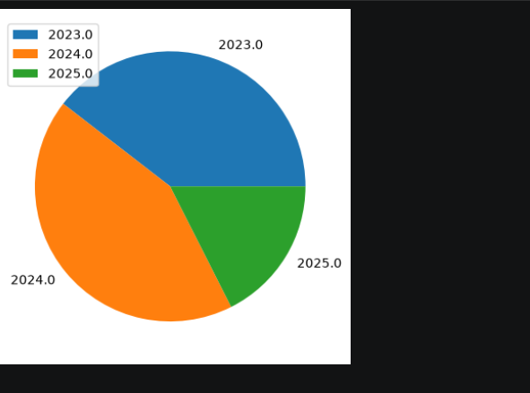

6.Conclusion

The data analysis for Smart Drop Company reveals a business with clear market strengths but facing data infrastructure challenges and a recent drop in sales velocity.
On the commercial side, Smartphones and Accessories in the Delhi region are the company's clear primary profit drivers. The balanced use of UPI, Credit Cards, and Cash also indicates a well-diversified checkout experience that accommodates various consumer preferences.
However, the analysis highlights two critical areas that require immediate attention:
- Severe Price and Ingestion Gaps: Imputing nearly 50% of the unit and base prices using dataset means poses a risk to financial accuracy. If these missing prices represent high-end items, the total revenue footprint may be significantly understated. Smart Drop needs to implement strict database validation constraints at checkout to ensure pricing data is fully captured.
- Sharp Financial Contraction: The 62.9% drop in revenue from 2024 to 2025, combined with a drop in customer signups, requires an immediate strategic response. If this decline isn't simply due to an incomplete 2025 dataset, the company must launch targeted marketing campaigns in top markets like Delhi and Mumbai [1]—particularly during the slower third quarter [1]—to stabilize sales volume and rebuild its customer acquisition momentum.

